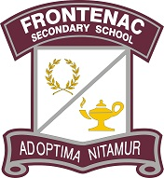

FSS Newsletter May 10th, 2024
Good afternoon Frontenac Families,
Here are some recent updates. We hope you have a wonderful weekend!
Regards, FSS Administration
Being Good Neighbours
This is a friendly reminder to all students and their families of the importance of being good neighbours to those who live and work around the school. Parents are reminded to avoid using the parking lots of neighbouring buildings and businesses for pick up and drop off. Students are reminded to stay off private property during the day, especially the common green spaces belonging to residents of the apartment buildings to the west of the school (484 Canatara Court). Thank you for your support with this.
Frontenac Falcons in the Spotlight
Student of the week: Zayn Ibn-Ali
Zayn is a student who emulates what it means to be a Falcon. She is a conscientious and articulate student, as well as a fierce advocate for her peers. She meets challenges and obstacles head-on, with an infectious positivity. We should all strive to be as dedicated and kind as Zayn!
Athlete of the week: Chloe Rioux
As a defender on the Junior Girls’ Soccer team, nobody can get by her! She is fierce, but nobody suspects it. Chloe is also a very clean player, and gets the ball by skill and determination. Chloe is a committed team member, who leads by example at practice by playing hard and focusing 100%. She is also kind, positive, and a great team player. The team depends on Chloe.
Yearbooks
Last chance to order 2023-2024 yearbooks! Visit ybpay.ca to order yours this weekend.
Frontenac School to Community
The School to Community class and some of our PAL buddies went to LCVI on Thursday, May 9th for a board-wide Spring Fling dance! The theme was NEON, and we had a blast! We enjoyed dancing until we dropped and meeting new friends. Next week, we are looking forward to hosting our own board-wide Soccer-Baseball Tournament in the FSS gym. Stay tuned!
Frontenac Student Services
Attention Graduates! Grad payments can be made via School Day until May 22nd. Grad fees ($40 per graduate) are found under the events tab. Grad tickets ($3 each) are found under the products tab. After May 22nd, tickets can be purchased at the front office of the school. Gowns and tickets will be distributed at the Grad breakfast on May 29th.
Advanced Placement Exams
A big congratulations goes out to all the students who wrote the English Literature and Composition Advanced Placement on May 8th. FSS had 18 writers this year; it was a fantastic day and the result of a lot of hard work, study, and commitment. The AP exam gives students opportunities to show their mastery of university-level content and can open doors for post-secondary enrichment. AP Calculus and Physics write Monday and Tuesday next week.
Schools Unlocked
The School Council would like to take this opportunity to thank all students, staff and community partners for making Schools Unlocked a smashing success on May 1st. With close to 40 booth presentations and performances by FSS drama and band, as well as the band from Acadie, the evening was a showcase of talent and a snapshot of school life.
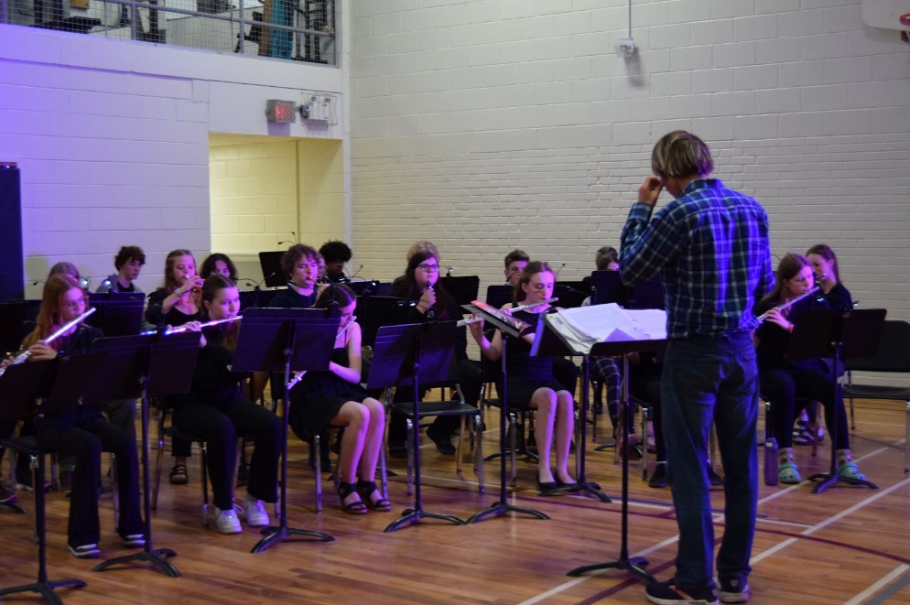

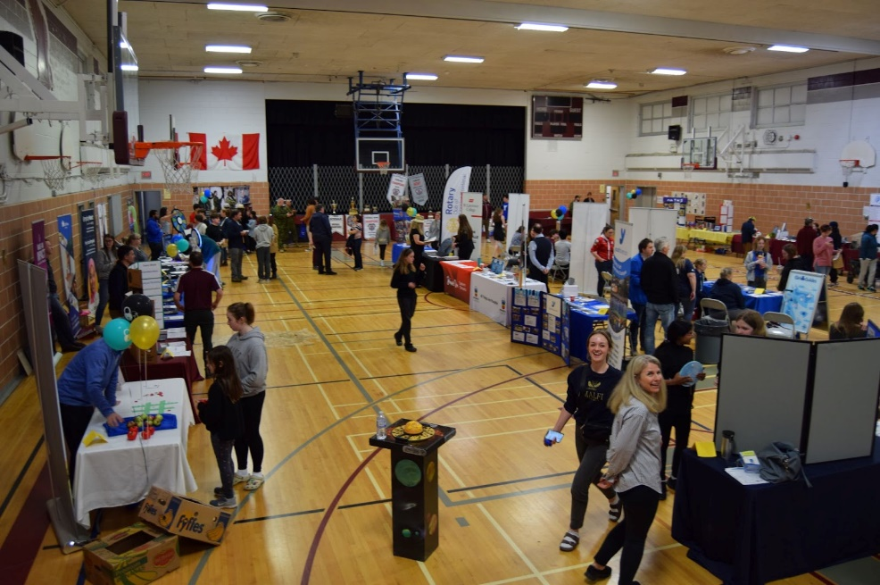
Frontenac Arts
Courtyard Piano: A huge thank you to Frontenac student Yasmine Toubache for repainting Frontenac's courtyard piano!
Wonderland Music Trip: On Tuesday, May 28th, members of the FSS bands and several classes will be performing at the Canada's Wonderland MusicFest again this year. Students will be adjudicated on their performance and will use this feedback to prepare for our upcoming concert on June 7th.
Spring Concert: Parents, guardians, friends and family are invited to enjoy our end of year concert featuring the various music classes and ensembles. The performance is fun, free and short! It will take place June 7th from 7:00 to 8:00 pm in the cafeteria. There will be a 50/50 draw to support the music department repair fund!
Hosting of International Students
Be a part of Kingston’s Global Community!

Would you like to give your family the experience of getting to know a student from another country? Demand for Kingston and Canada as a learning destination is rapidly expanding. Limestone is proud of a rich tradition of hosting students from other counties. Students from over 15 different countries are here now staying with great homestay families.
Host families will be paid a tax-fee monthly stipend to host students. All students in the program attend local intermediate or secondary schools and range in age from 12-17. We work hard to make a great match for your family that can last a lifetime!
Interested? For more information, please contact us at:
https://internationaled.limestone.on.ca
Instagram: @limestone_international_ed
Office Phone: (613) 544-7745 x290
APPLY HERE!
AMHS-KFLA Problem Gambling Support
Please see the poster below for information about support for parents of youth ages 13 and older with concerns about video games. Basic information about gaming (including terms) and microtransactions will be provided, along with pros and cons of gaming, warning signs, and tips for setting screen time rules and having hard screen-related discussions with children. This is a drop-in group with no charge for parents. There will be time for questions, answers, and discussion in a non-judgmental environment.
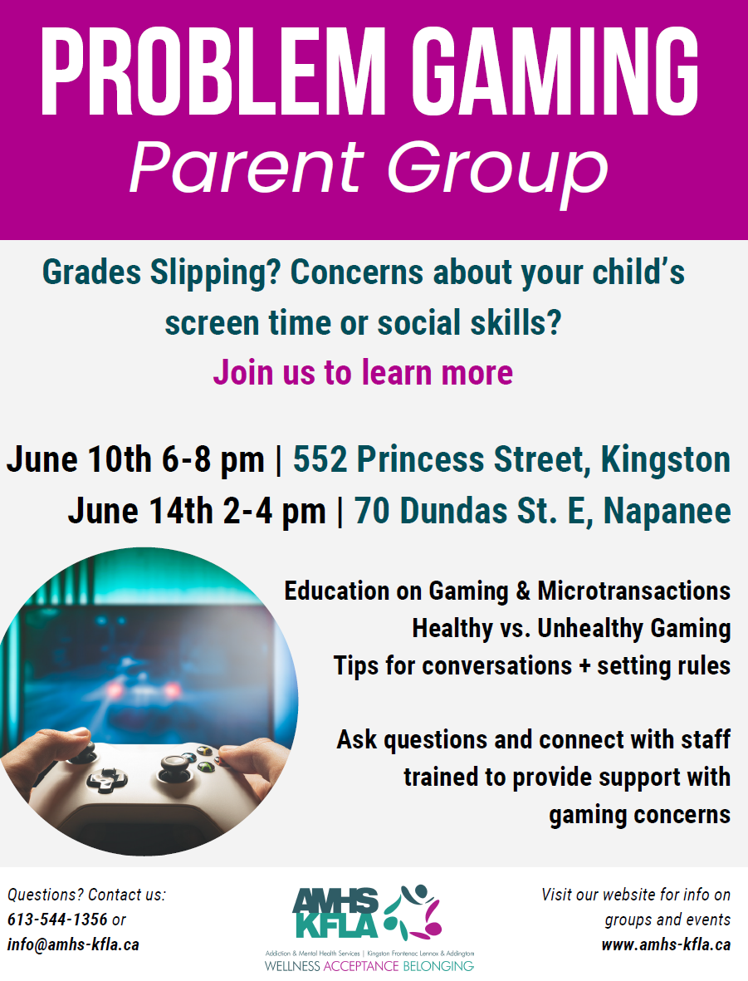
Free Tutoring Support Through Queen’s
HYPE is a free tutoring program that allows Queen’s students to give back to their community by volunteering and providing 1-on-1 or group tutoring services for local Kingston secondary school students. They will be hosting all group tutoring, 1-on-1 sessions, and workshops in person or online. We offer tutoring for a wide variety of subjects, including Math, Science, English and more. Here is the link for the form to sign up for free tutoring services.

Semester 2 Exams
Second semester exams are scheduled for June 20th-26th , with grade 12 final summatives starting on June 18th. Detailed exam schedules have already gone home. Students that notice a conflict are asked to connect with Ms Jones if they have not already done so. Students will not be allowed to write exams at other times because of family vacations. Students are expected to be present and available to write exams during the entire exam period.
Summer School
Registration for the Summer Session officially opened on May 1st, 2024. The last day to register is June 24th, 2024. Students wishing to register should speak to their Guidance Counsellor.
Grade 9 - Marie Dempster
Grade 10 - Krista Lackey
Grade 11 - Aaron Kenney
Grade 12- Angie Lowry
At a Glance: Upcoming Events at Frontenac
May 22: Olympiad (whole-school event)
May 29: Grad Breakfast
May 31: PA day
June 7: Spring Concert
June 18&19: Grade 12 Final Summatives begin.
June 20-26: Semester 2 exams
June 27: Graduation

Phone 613-389-2130
Email fross@limestone.on.ca
