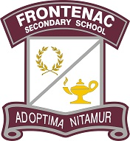

Frontenac Students, You're Invite to The Ultimate Study Guide
Who: All students presented by Queen's University's CPOP (Clinical Psychology Outreach Program)
What: Study session to learn about effective test preparation, note taking strategies
When: Thursday, January 11th at lunch
Where: FSS Library Learning Commons
Why: To prepare for your upcoming exams and to finish semester 1 strong
The Ultimate Study Guide is a lunchtime presentation for all students with a focus on organization, test prep, and self-care. This workshop will cover effective and proven note taking strategies for students with a focus on 'being present' at school. No registration is necessary. We hope to see you there!
See attached poster for more info: Study Skills Poster
Sincerely,
FSS Administration

