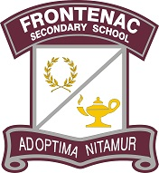


Parent Council Meeting Tomorrow
Good morning Acadie and FSS families,
Our next School Council meeting will be held on Thursday, February 22nd from 6:30-8:00pm in the Frontenac Library Learning Commons. We look forward to hearing from you and answering any questions our parent/ caregiver community may have, even if you’ve never attended before, we’d love to hear from you.
Kind regards,
Frontenac & Module l’Acadie Parent Council

Frontenac Secondary School Phone 613-389-2130
Frontenac Secondary School Email fross@limestone.on.ca
Module de l’Acadie Phone 613-389-0091
Module de l’Acadie Email edaca@limestone.on.ca


