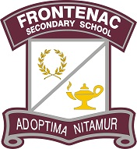


Parent Council Meeting Tomorrow
Good morning Acadie & FSS families,
You're invited to our Parent Council meeting tomorrow evening. We look forward to connecting with families on Wednesday, January 31st from 6:30-8pm in the Frontenac Library Learning Commons. Trustee Garrett Elliott will also be attending the meeting to answer any questions our parent/ caregiver community may have.
Kind regards,
Your Parent Council

