Good afternoon Frontenac Families,

Suddenly, summer weather has appeared. We hope you have a wonderful weekend!
Regards, FSS Administration

Being Good Neighbours

We continue to remind and encourage all students and their families of the importance of being good neighbours to those who live and work around the school. Parents are reminded to avoid using the parking lots of neighbouring buildings and businesses for pick up and drop off. Students are asked to stay off private property during the day, especially the common green spaces belonging to residents of the apartment buildings to the west of the school (484 Canatara Court). Thank you for your support with this.

Frontenac Falcons in the Spotlight

Anthony Ayalya-Pain is the student of the week. Anthony in his fashion class continues to demonstrate amazing creativity and entrepreneurship. Anthony is currently working hard to grow his clothing brand KereSchaos. His hard work, creativity and desire to be successful has been infectious to others around him.
"Keep it going Anthony"

Wyatt Lee has taken the Track and Field world by storm. He is a natural athlete who has seemingly come out of nowhere to become the fastest junior boy in the city. At the KASSAA Track and Field Meet earlier this month, Wyatt won the 100m in a time of 11.11seconds, just 0.21 off the meet record. Wyatt then ran the 200m dash in a time of 22.69seconds, which broke the previous record of 23.30 set in 2007. Wyatt draws attention from all who are at the track with his explosive speed and consistent performances. He will be a person to watch in the years to come on and off the track! Good Luck to Wyatt this week at EOSSAA!

Olympiad a Smashing Success

Olympiad 2024 was an event to remember! Perfect weather, fun activities, and a ton of school spirit. We are already looking forward to next year.

In addition to students, staff, and admin that worked so hard to make Olympiad happen, Student Council would like to thank: Dominos for providing pizza lunch at a reduced cost, Pepsi for donating drinks, Luv-A-K9 for visiting with their team of therapy dogs, School Council and Jeff Towers (Falcon Parent) for their generous donations. Your support is very much appreciated!
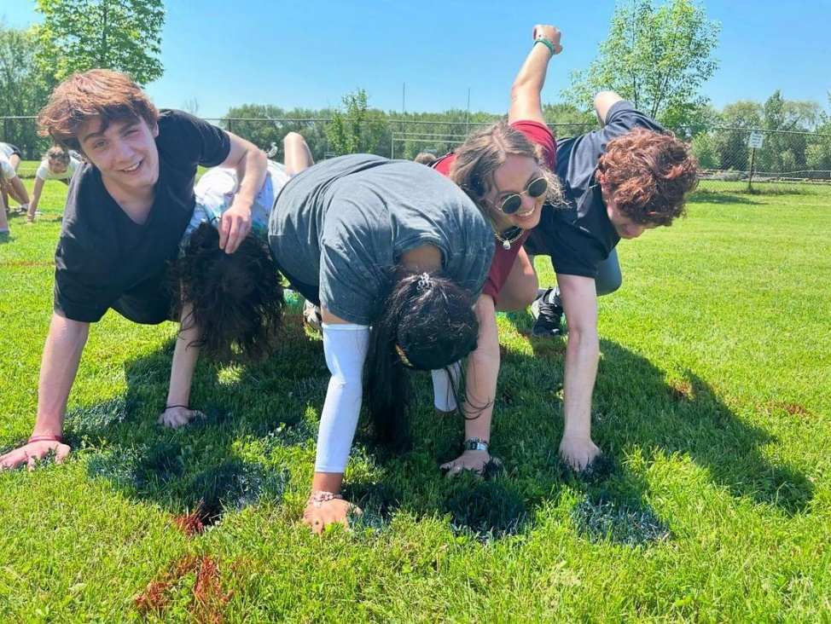

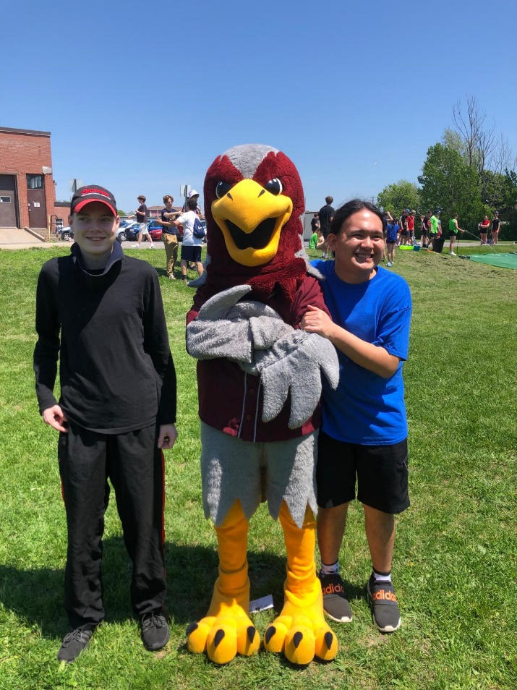

Frontenac School-to-Community

Thank you again to both FSS and Acadie for accommodating our Soccer-Baseball tournament May 15th. The kiddos had a blast, and we had teams come from BSS, LCVI, SHS, HCSS, RND, KSS and ESS!

Huge shout-outs go to:

- The School to Community staff for supporting our students
- Mr. Cowan and his leadership class for organizing and facilitating the games (we have some amazing student leaders in our school!)
- Ms. Franchetto and the PAL class for helping run the day
- Ms. Pixley for helping to finish off the day and the phys-ed classes for letting us use the gyms
- Caretakers Ryan and Mike for making sure everything was running smoothly and for helping with clean up

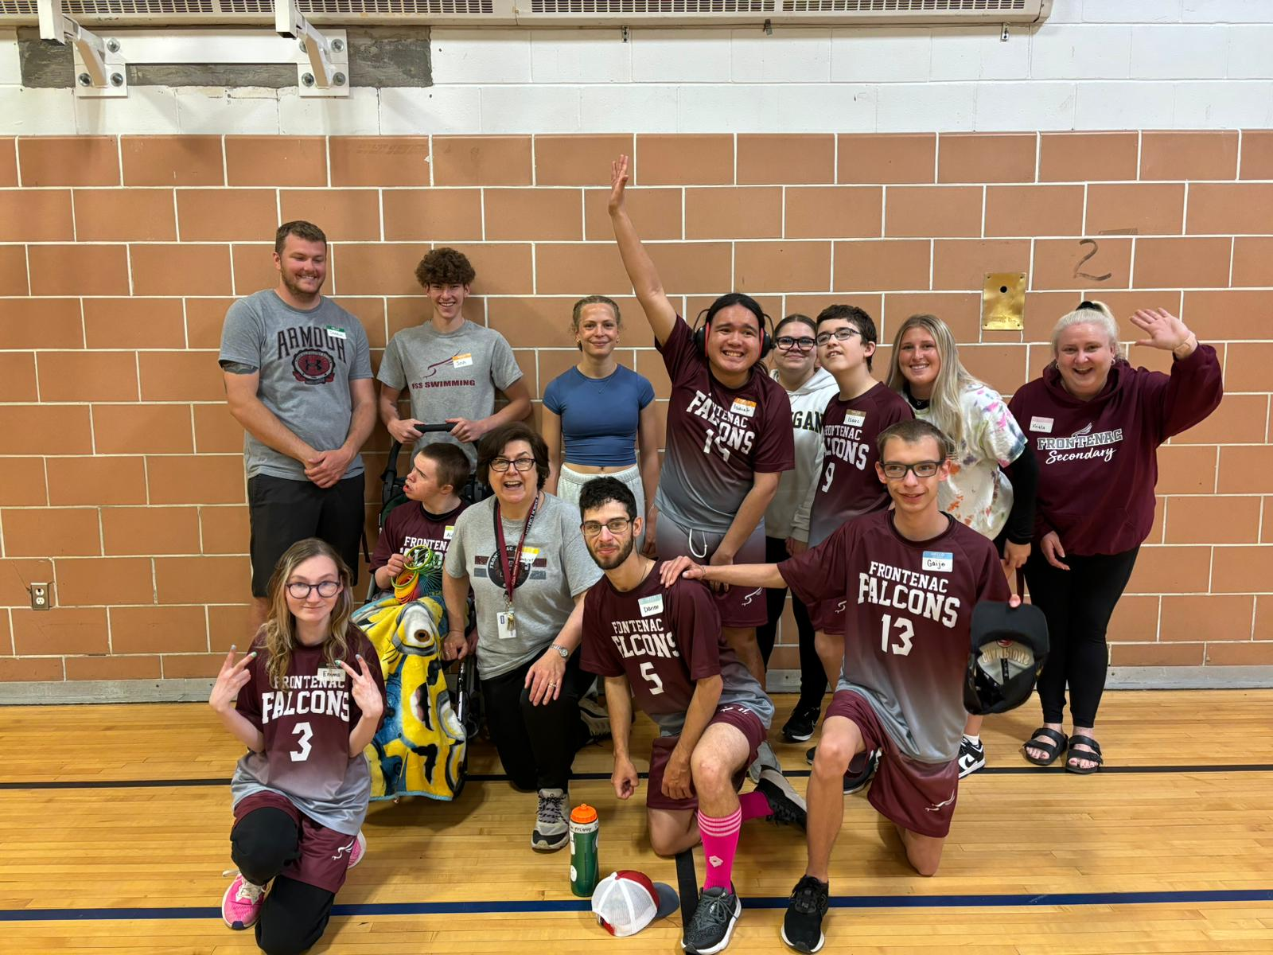

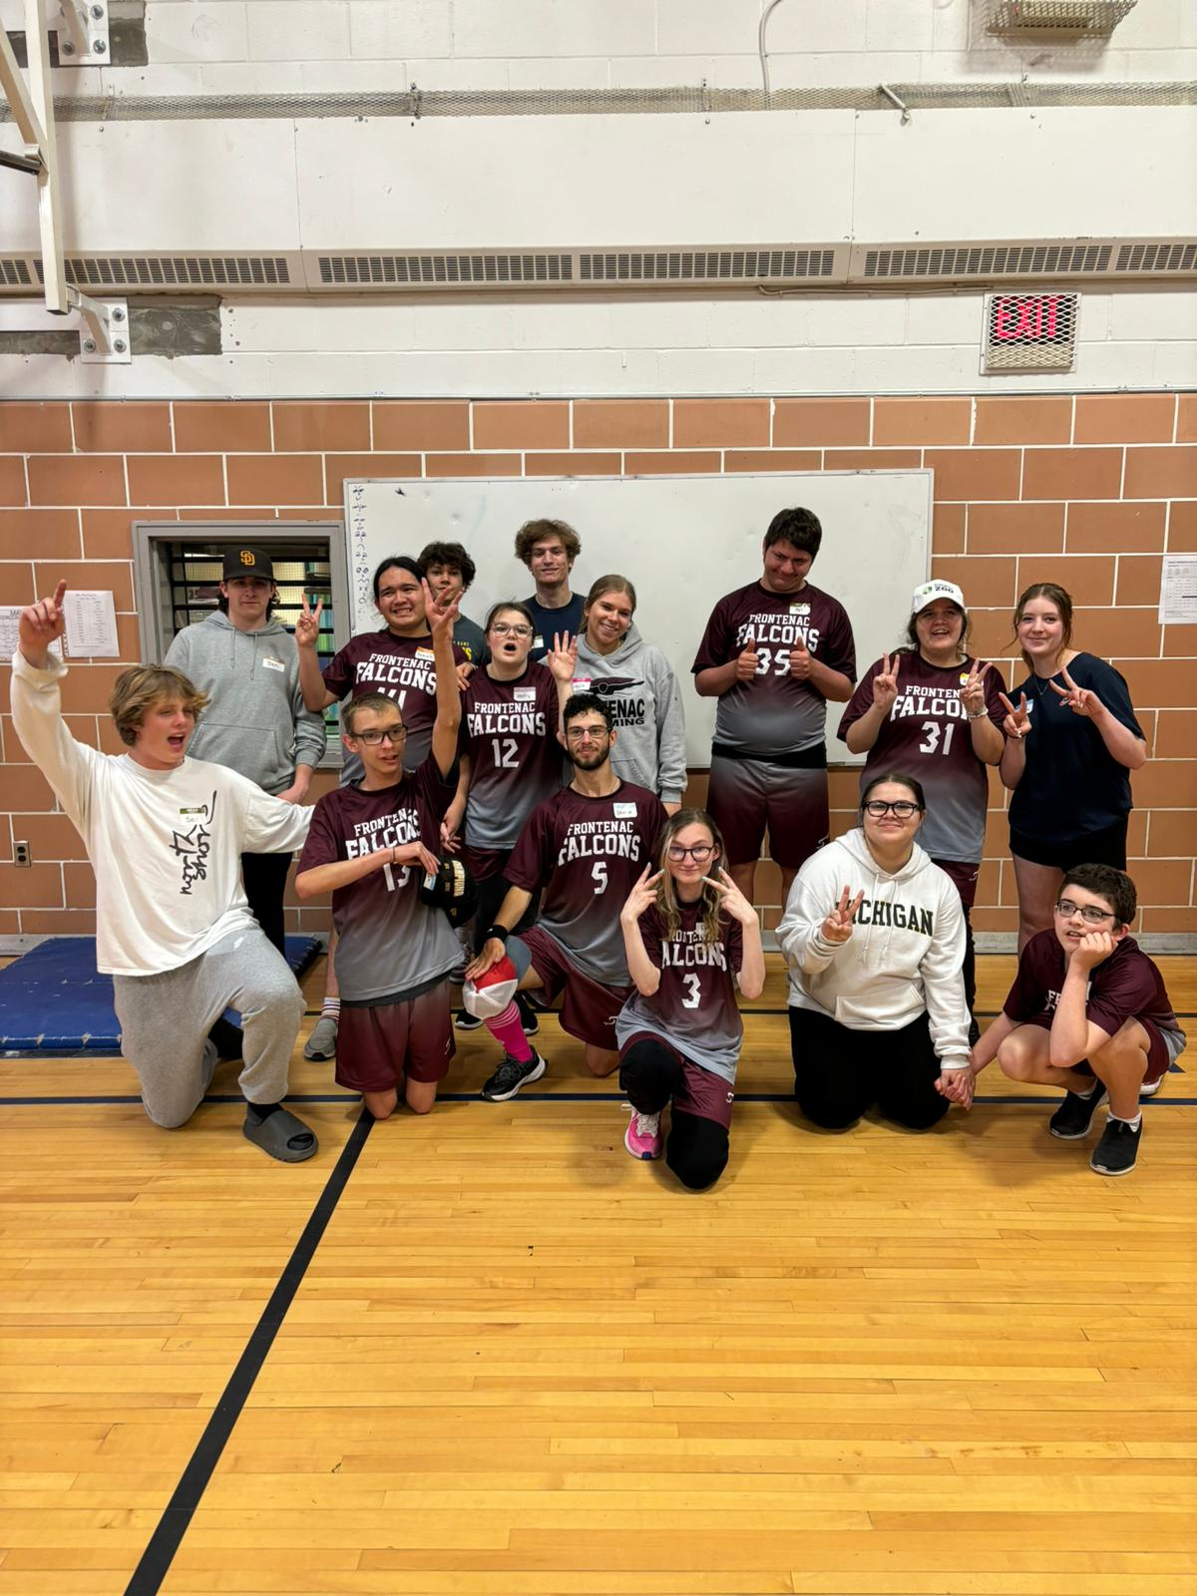

Frontenac Student Services

The Grad Breakfast is happening Wednesday, May 29th in periods 1 & 2! Graduates will enjoy breakfast, learn important details about the upcoming graduation ceremony, and receive their Gowns & Tickets! Please Note: The deadline to pay for Grad Fee and purchase Tickets on School-Day has now passed. From now on, these purchases can be completed by debit or credit with Vicki Gower in the Main Office. We look forward to gathering the Class of 2024 one last time before their Commencement Ceremony at The Slush Puppie Place on Thursday, June 27th at 12:00 noon!

Frontenac Arts

Courtyard Piano: A huge thank you to Frontenac student Yasmine Toubache for repainting Frontenac's courtyard piano!

Wonderland Music Trip: On Tuesday, May 28th, members of the FSS bands and several classes will be performing at Canada's Wonderland MusicFest again this year. Students will be adjudicated on their performance and will use this feedback to prepare for our upcoming concert on June 7th.

Our final Concert will take place In the Frontenac cafeteria on June 7th from 7:00 to 8:00 pm. The admission is free, but if you want to bring a couple of loonies we will host a 50/50 draw if you are interested in participating.
The concert will involve performances from the students in the current music classes as well as the various ensembles.
- Grade 9/10 Immersion
- Grade 9 Music
- Grade 11/12 guitar
- Concert Band Level 100, 200 and 300
- Strings Ensemble
- Percussion Ensemble
- Jazz Ensemble
Please help us to make Frontenac the place to be Friday Night June 7th!
Thanks for supporting the arts!

FSS Trivia Team

The Trivia Team hosted its first ever local tournament on May 23rd. The Seniors won gold with a whopping 1020 points, and the Juniors came out in third! It was a great way to conclude a fantastic season. Special shout out to graduating players Owen and Ari. We look forward to resuming the club in September. New members are always welcome.

Hosting International Students

Be a part of Kingston’s Global Community!

Would you like to give your family the experience of getting to know a student from another country? Demand for Kingston and Canada as a learning destination is rapidly expanding. Limestone is proud of a rich tradition of hosting students from other counties. Students from over 15 different countries are here now staying with great homestay families.
Host families will be paid a tax-fee monthly stipend to host students. All students in the program attend local intermediate or secondary schools and range in age from 12-17. We work hard to make a great match for your family that can last a lifetime!
Interested? For more information, please contact us at:
https://internationaled.limestone.on.ca
Instagram: @limestone_international_ed
Office Phone: (613) 544-7745 x290
APPLY HERE!

AMHS-KFLA Problem Gaming Support

Please see the poster below for information about support for parents of youth ages 13 and older with concerns about video games. Basic information about gaming (including terms) and microtransactions will be provided, along with pros and cons of gaming, warning signs, and tips for setting screen time rules and having hard screen-related discussions with children. This is a drop in-group with no charge for parents. There will be time for questions, answers, and discussion in a non-judgmental environment.



Free Tutoring Support Through Queen’s
HYPE is a free tutoring program that allows Queen’s students to give back to their community by volunteering and providing 1-on-1 or group tutoring services for local Kingston secondary school students. They will be hosting all group tutoring, 1-on-1 sessions, and workshops in person or online. We offer tutoring for a wide variety of subjects, including Math, Science, English and more. Here is the link for the form to sign up for free tutoring services.

Semester 2 Exams
Second semester exams are scheduled for June 20th-26th , with grade 12 final summatives starting on June 18th. Detailed exam schedules have already gone home. Students that notice a conflict are asked to connect with Ms Jones if they have not already done so. Students will not be allowed to write exams at other times because of family vacations. Students are expected to be present and available to write exams during the entire exam period.

Summer School

Registration for the Summer Session officially opened on May 1, 2024. The last day to register is June 24, 2024. Students wishing to register should speak to their Guidance Counsellor.
Grade 9 - Marie Dempster
Grade 10 - Krista Lackey
Grade 11 - Aaron Kenney
Grade 12- Angie Lowry

At a Glance: Upcoming Events at Frontenac
May 29: Grad Breakfast
May 31: PA day
June 7: Spring Concert
June 13: Athletic Banquet 4:00 PM Main Gym
June 14: Arts Banquet 4:00 PM Cafeteria
June 18&19: Grade 12 Final Summatives begin.
June 20-26: Semester 2 exams
June 27: Graduation

