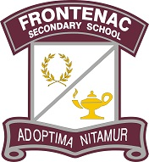


You're Invited to Grade 8 Parent Information Night
Hello Acadie & Frontenac Families!
Just a reminder that our Grade 8 Information Night is happening this evening from 7:00-8:30 PM at FSS! We'll be kicking things off with a Presentation in the Library Learning Commons followed by classroom drop-Ins where families can meet staff from each department and ask questions.
Please see the following poster for more info: Grade 8 Night.png
Hope to see you there!
-The FSS Student Services Team

